Monthly PLR Income Stream

Monthly PLR Income Stream

“Learn How To Monetize PLR Content & Create Multiple Streams Of Income Today!”

LEGAL NOTICE

The Publisher has strived to be as accurate and complete as possible in the creation of this report, notwithstanding the fact that he does not warrant or represent at any time that the contents within are accurate due to the rapidly changing nature of the Internet.

While all attempts have been made to verify information provided in this publication, the Publisher assumes no responsibility for errors, omissions, or contrary interpretation of the subject matter herein. Any perceived slights of specific persons, peoples, or organizations are unintentional.

In practical advice books, like anything else in life, there are no guarantees of income made. Readers are cautioned to reply on their own judgment about their individual circumstances to act accordingly.

This book is not intended for use as a source of legal, business, accounting or financial advice. All readers are advised to seek services of competent professionals in legal, business, accounting, and finance field.

You are encouraged to print this book for easy reading.

TABLE OF CONTENTS

Explode Your Monthly Income Through Monthly PLR Sites! 2
“Learn How To Monetize PLR Content & Create Multiple Streams Of Income Today!” 2
TABLE OF CONTENTS 3
Chapter 1: Introduction 5
Chapter 2: Why Monthly PLR? 7
Chapter 3: How to Choose A Good Monthly PLR Site 9
Chapter 4: How to Utilize
PLR E-books 11
Chapter 5: How to Utilize PLR Sales Letters And Landing Pages 13
Chapter 6: How to Utilize
PLR Articles 15
15
Chapter 7: How to Make Money Using Thank You Pages 17
17
Chapter 8: How to Make Money Using Autoresponder E-Courses 18
Chapter 9: How to Make Money Using PLR Blog Posts & Themes 19
Chapter 10: How to Make Money Using Video And Audio 21
21
Chapter 11: Summary 22

Monthly PLR Income Stream

“Learn How To Monetize PLR Content & Create Multiple Streams Of Income Today!”

Chapter 1: Introduction



Welcome to “Monthly PLR Income Stream!”

In this E-book, you will discover important strategies on how to monetize Private Label Rights content through membership subscription.

Everyone knows that PLR sites are a highly lucrative business model. There are many people who are good at mass producing PLR content, but what about the END USER?

Not everyone is good at monetizing it. So many of them subscribes as a member to these membership sites but few actually have the knowledge to monetize them to the MAX!

In this E-book, we will take a closer look at PLR content that is available for the majority of membership sites out there.

We will explore how to make use of:

- E-books
- Sales letters
- Landing Pages (or Squeeze pages)
- Articles
- Thank you pages
- E-courses
- Blog Posts
- Blog Themes
- Videos and Audios

So without further ado, let’s jump into it right away!

Chapter 2: Why Monthly PLR?



Most of the time, people are afraid of monthly commitments, that is why they are afraid to join monthly PLR sites.

That is NOT the right way to think!

The advantages of joining a monthly PLR membership site are as follows:

- It can be a lot cheaper compared to buying from other sources because monthly subscriptions are usually a lot cheaper than one time purchases.

- You get consistent content every month!

- You get to monetize the LATEST, hottest, new niches! With new monthly content, you can be sure you will not be using OLD, outdated content.

- You get to create multiple streams of incomes when you really push yourselves to work hard every month.

- You get the privileges of exclusivity. Because monthly content are not easily available to the public, you do not compete with tons of other Internet marketers (or niche marketers) that are recycling the SAME, overused content over and over again! The only people you are ‘competing’ against are the people who has membership access and there is usually a membership cap to a PLR membership site.

- You also get to enjoy first mover’s advantage! You will know exactly when the content will be released and you can start loading up the content on your sites as quickly as possible. After all, the early bird get’s the word, right?

Now that we are very clear why PLR memberships are one of the best investments one can make, we will have to choose the right membership site!

The next chapter will show you how to choose the ‘best’ one.

Chapter 3: How to Choose A Good Monthly PLR Site



Let’s be realistic here…

Not all PLR membership sites are created equally – some of their content is just BAD, while others are produced with premium quality!

Therefore, it is very important that you check out the credibility of the founders of the PLR site.

Make sure they have:

- A proven track record
- Are capable of producing EXCELLENT content (After all, content is king)
- Are backed by SOLID testimonials.

Once you know WHO to buy from, you must take a look at the list of content they are providing – whether they are suitable for your needs, whether it is too pricey, or whether you will be able to monetize it.

You have to be sure as well if the niches you are focusing on are targeted, generic or too competitive.

Here is a list of criteria that will assist you in your search:

- TOP Quality content – It is the most important criteria of them all! (If you want to check out the quality of past issues, you can do a search on Google to see if anyone published the content on their website – this is a useful way to gauge the quality of the site without investing in it).

- Powerful graphics – If they are provided, you can greatly increase your conversion rates. And also, do they provide Photoshop PSD files that you can use to edit and rebrand?

- Monetization methods they cater for – Do the content allow you to monetize many ways such as Google AdSense, Amazon affiliate, Clickbank, Chitika, Commission Junction or even publishing your own E-book?

- Does it provide high converting sales letters and opt-in pages to capture leads for your mailing list? This is very important because you want everything to be set up for you!

- Does it provide good quality audio and video products?

Chapter 4: How to Utilize
PLR E-books

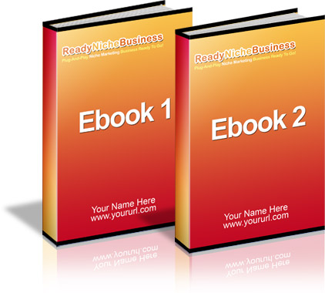

E-books are very important. Most PLR sites provide E-books as the bread and butter of the entire business model.

Here are some of the best strategies on how to utilize PLR E-books:

- Put your name on the products as the author – This is the most obvious benefit of them all. Private Label Rights allow you to claim authorship to the E-book and you can use it to build your name/brand or sell it.

- Edit the contents – You can change the titles, edit the product contents, insert your affiliate links, and/or paste your own advertisements into the products. These are just some ways to monetize in addition to the profits you are making from selling the E-book.

- You can take the content in the book and arrange them into your very own articles (more about monetizing articles in the subsequent chapters).

- On the other hand, you can also take a few PLR E-books and combine them together to create one HUGE mega E-book and sell them for profits.

- You can shorten the E-book by taking out the key points and turn it into a special report that you can use either as a teaser to get people to buy your E-book or you can use it to capture leads.

- Depending on the terms and conditions, you can use this book and give it away as a bonus to products you are already selling.

- You can also offer additional rights to your E-book that will enhance the perceive value (e.g. basic resell rights, master resell rights or even re-branding rights).

These are just some examples that you can use to monetize E-books because you can use your imagination to come up with additional ideas how to market yourself with PLR E-books.

Chapter 5: How to Utilize PLR Sales Letters And Landing Pages

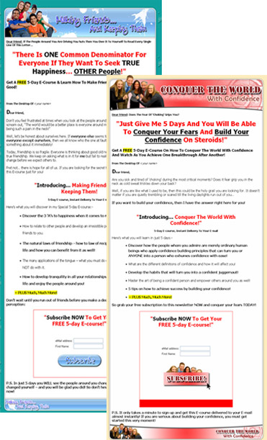

Sales Letters and landing pages are one of the most important components you must utilize when you are setting up your profit funnels.

Here are the best ways you can utilize them:

- You can save a tremendous amount of time and money by filling in your name and uploading your payment processor and upload them immediately.

- You can even add your own products by editing the ready made sales letter and offer bonuses to entice buyers to make a purchase.

- Use the sales letters as swipe files for new sales letters that you plan to write for yourself – this is very useful when you are a budding copywriter and you want to learn from the best!

- Landing pages will effectively help you capture leads and build your list quickly.

- Combine your landing pages with special reports (See chapter above) and autoresponder E-courses, you will be able to create a sales funnel that will turn the casual prospect into a paying customer.

- Use landing pages to lead your prospects to thank you pages that you can use to monetize additional affiliate sales (More on how to utilize thank you pages in the next chapter).

- You can also use the landing page to direct your prospects immediately to your sales letter (Use them hand in hand).

Chapter 6: How to Utilize
PLR Articles



There are MANY advantages of having PLR articles.

Here are a few examples on how to utilize them besides selling them for money:

- Design your own physical or digital newsletter.

- Build massive traffic to your Website through Article Directories. Submit your articles to high page rank directories like E-zine articles and have your article appear in various niches. You can also insert your own name as the author in your own bio box and drive visitors to your home page.

- Become an expert in your field by branding yourself with high quality articles.

- Keep your mailing list alive by keeping in touch with them! Give them quality articles that feeds their need to read something new everyday or once in a while

- You can also use PLR articles to get Google to rank your site as quickly as possible! Remember, Google takes a while to rank your site so make sure you send articles regularly and the Google spiders will index your site more and more frequently. But make sure you post up relevant articles!

- Increase your AdSense earnings with your articles. You can also monetize your articles using Kontera.

- You can also compile all the articles together to create your own E-book or special report!

- You can even use articles for viral marketing!

Chapter 7: How to Make Money Using Thank You Pages

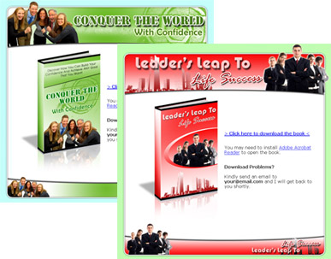

‘Thank you’ pages are one of the most overlooked strategies. Most people think that they are just there as a courtesy to thank the customer, but there is more to it than meets the eye!

You can use a ‘Johnson Box’ to get the reader’s attention and do the following:

- Promote an affiliate program
- Recruit affiliates for programs that pay on two-tiers.
- You can also direct traffic to your own site and recruit affiliates
- Sell your own products.

Chapter 8: How to Make Money Using Autoresponder E-Courses

You can set up your own newsletters, E-zines and E-courses as well!

Here are some suggestions:

- Quickly upload your PLR E-zines to your autoresponder and use it to build a relationship with your list.

- Create your own physical or digital newsletter and sell your own (or your affiliate) products within

- Charge clients money to include their products in your E-zine.

- Create multiple E-zines and build many different lists (In different niches) very quickly!

- Once again, keep people within your lists. This is a good way to see if they are ‘active’ members or not because people tend to forget who you are if you do not keep in touch with them. If they unsubscribe from your list as a result of you sending them E-mails from your E-zine, then it is a good sign as well because you will want to know WHO is reading your E-zines and who isn’t!

- You can also quickly upload your E-courses to pre-sell your list on your E-books!

Chapter 9: How to Make Money Using PLR Blog Posts & Themes

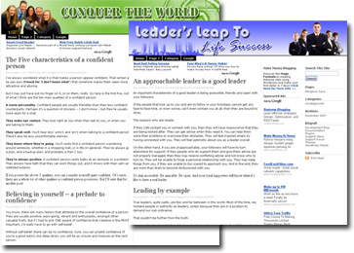

PLR Blog themes and blog posts are also a very unique way to diversify your income streams.

What you can do is you can quickly change the header title for your blog.

Then you can install Wordpress on your hosting account and upload the blog themes onto your hosting.

You use blog posts that are provided for you to jumpstart your blog by uploading one blog post at every interval (Everyday or every 3 days, it is up to you how frequently you want to keep in touch with your readers).

There are many ways you can monetize PLR blog posts and themes – create multiple blogs quickly, make money with AdSense, Kontera, Pay Per Post, Review me, Text-link-ads and many more!

Chapter 10: How to Make Money Using Video And Audio



Last but not least, videos and audios are one of the ways to take your business to the next level! (Without being an expert photographer, interviewer or camera man!)

Use it to:

- Enhance your product’s value by offering audio and video as a bonus to the main E-book!

- Bait people to come to your site or upload videos on YouTube and watch as the traffic SWARM to your website!

- Cater to more markets by targeting those who prefer to listen to an E-book being read or the visual type.

Chapter 11: Summary



After reading through this book, I’m sure you will take away a couple of ideas that will give you a clear understanding why being a member of monthly membership sites will give you a clear advantage over the rest of the Internet marketing crowd.

The most important thing you must remember is this – speed is the key!

One of the most important selling points of PLR is to help people save time, money and effort! But most of the time, you will find people who buy PLR products but they let the products virtually ROT in their hard drive.

Don’t be like most people.

Make sure you take action and get started immediately and get ready to EXPLODE your monthly income!

To your Success!

